Title: Partnering with MIT Amphibious Achievement

Photos for Section:

UPDATE (Ye): New photos chosen are shown below.

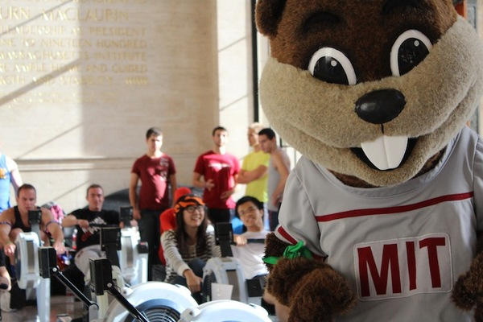

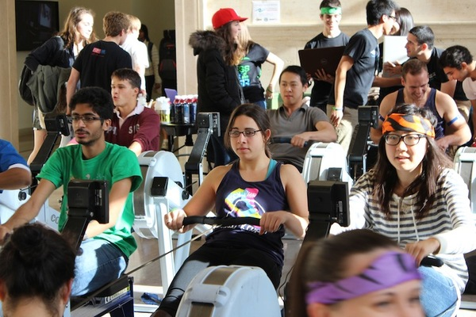

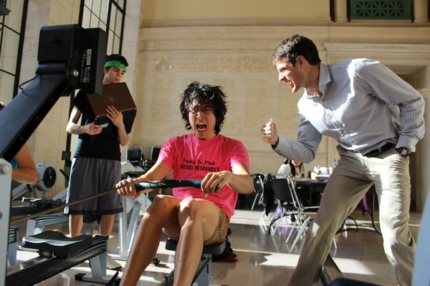

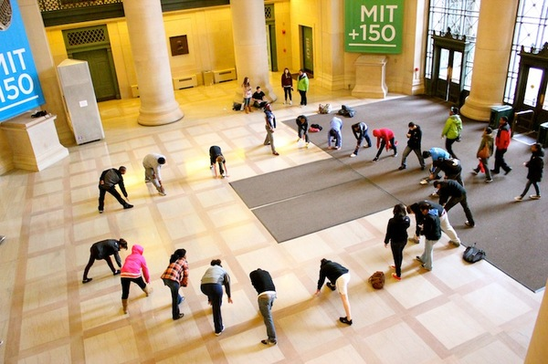

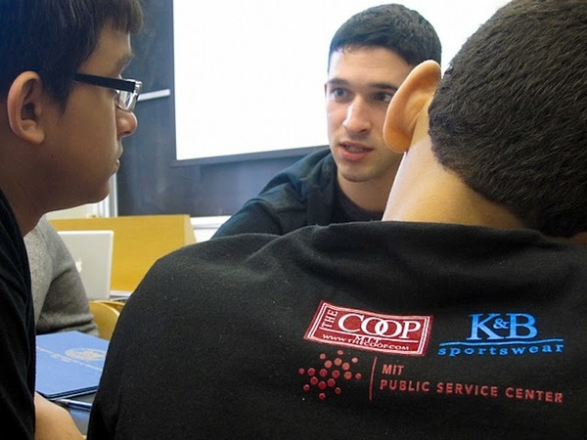

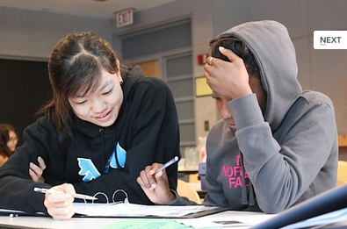

Text:

*“Phyo was mostly involved with the rowing portion of the program, and would come every week to the MIT D1 boathouse to help coach Achievers. His dedication and passion to helping Achievers reach their goals was inspirational. In this video* [*here*](http://vimeo.com/42035580#at=0) *(at 1:18s), you can see Phyo rowing alongside the Achievers as they strive to beat their Personal Record (PR) on the erg.”*

*- Noam, Co-Founder of Amphibious Achievement*

The PN2K Memorial Foundation is partnering with MIT Amphibious Achievement, a dual athletic and academic mentorship program for urban youth in Boston-Cambridge where students (called Achievers) better themselves through aquatic sports and college preparatory tutoring sessions at MIT. In the past two years, this annual event has been held in the Infinite Corridor, Lobby 10 – a very hard miss! The location and date of the 2013 MIT Amphibious Achievement Erg-a-Thon challenge are to be determined. Don’t forget to jump on an erg and show off your stuff on the day.

PN2K and MIT Amphibious Achievement are collaborating on three main initiatives:

**Project 1: Amphibious Achievement Erg-a-Thon**

Of funds raised, $500 will go towards The Phyo Nyi Nyi Kyaw Achievement Award, a joint scholarship award made possible by the efforts of MIT AA and PN2K, set up in memory of Phyo and awarded to a high-performing Achiever each year. This Achievement Award will fully fund the Achiever’s four years of participation in the AA program.

**Project 2: Mentorship Support**

PN2K will be working to develop a lifelong mentorship program for Achievers that will last beyond the four years they spend with MIT AA. This mentorship program will be open to Achievers who meet the writing eligibility criteria (a fun writing activity – more details on this to come later!) and apply for the Phyo Nyi Nyi Kyaw Achievement Award (see above). The mentorship program aspires to leverage existing networks of young professionals to create a supportive community that will help open doors of opportunities for Achievers, both in the form of college application support and internship opportunities.

Want to be a mentor or want to nominate someone? Contact us at [pnnk-director@mit.edu](mailto:pnnk-director@mit.edu) or visit our “Contact Us” page.

**Project 3: Achiever’s blogs**

Achievers will be engaged in fun, inspirational, comical, or whatever genre of storytelling through creative writing exercises through the PN2K platform. These activities, along with occasional writing tips provided by their AA and PN2K mentors, will allow them to strengthen their critical writing, a powerful skill to learn no matter what field. On a more personal level, the recipients of the Phyo Nyi Nyi Kyaw Achievement Award will be featured on our website – We hope their life blogs on overcoming challenges will inspire others to follow.

Check out the Amphibious Achievement website for more information and updates:

<http://amphibious.mit.edu/>

Video:

Comment for Amphibious Achievement Partnership section:

* If possible, I am imagining something that separates the three sections from each other clearly so it’s not one long paragraph of boring text. For example, three separate sections, one each on the erg-a-thon, the mentorship support, and the blogging.
* We don’t have this yet, but eventually, provide a link to “Check out the Achievers’ blogs”
* More info to add as we receive news.
* The erging video link URL is <http://vimeo.com/42035580#at=0>
* Excellent! Would just check with AA that we can use their photos.
  + Sent out an email.